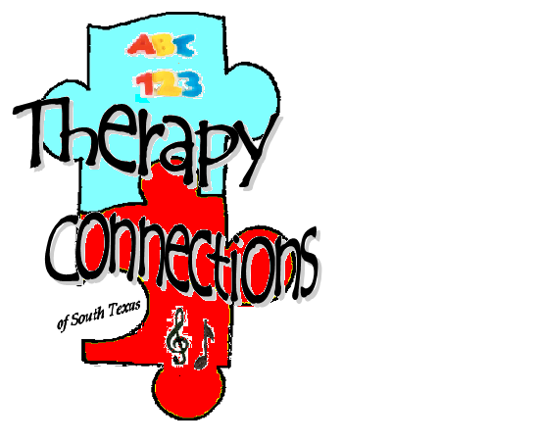
Therapy Connections
of South Texas

Specializing in Direct & Consultation
Music Therapy & Applied Behavior Analysis Services
for individuals with autism and other developmental disabilities

INTAKE FORM

The following information is to be completed by the child’s parent or legal guardian. This form has been designed to provide essential information before your initial appointment in order to make the most productive and efficient use of our time. Please feel free to add any additional information which you think may be helpful in understanding your child. All information provided by you is strictly confidential and will only be released in accordance with HIPPA guidelines. Thank you!

Robin Palmer Blue, MA Ed., BCBA, MT-BC
Client Information

Child’s Name:___________________________________________________________ DOB:___________________

Address:_____________________________________________________________________________________________

____________________________________________________________________________________________________

Parent’s Name(s):_____________________________________________________________________________________

Home #:________________________________ Primary e-mail address:_________________________________________

Mother’s Work #:_________________________________ Cell #(s):______________________________________

Father’s Work #:_________________________________ Cell #(s):______________________________________

Sibling name(s) and age(s):______________________________________________________________________________

____________________________________________________________________________________________________

Primary Diagnosis:________________________________ Secondary Diagnosis:________________________________

Age at diagnosis:___________ Diagnosed by whom:_______________________________________________________

Additional information:__________________________________________________________________________________

____________________________________________________________________________________________________

Insurance: PLEASE PROVIDE ENLARGED COPIES OF INSURANCE CARD(S) – FRONT AND BACK

Primary: ____________________________________________________ ID#:____________________________________

Member Name:_________________________________ SS #:_________________________ DOB:____________________

Secondary: ___________________________________________________ ID#:____________________________________

Member Name:_________________________________ SS #:_________________________ DOB:____________________

Emergency Contact Information (if unable to reach parents directly):

Name:___________________________________ Phone:____________________ Relationship:__________________

Name:___________________________________ Phone:____________________ Relationship:__________________
Page 2

Medical Information
Current Medication(s):_______________________________________________________________________________________

____________________________________________________________________________________________________

Allergies:_____________________________________________________________________________________________

____________________________________________________________________________________________________

Special Dietary Needs/Restrictions:_____________________________________________________________________________________

____________________________________________________________________________________________________

____________________________________________________________________________________________________

Other Medical Information:___________________________________________________________________________________________

____________________________________________________________________________________________________

General Questions
What are your immediate goals for your child?

How would you describe your child & things you would like us to know about your child? - strengths, personality, etc.

What current communication skills does your child have? (vocal, sign language, PECS, augmentative communication device, etc.) Please explain what degree of functional communication your child has.

Please check all that apply:
Expressive: ___Babbles ___Repeats words/perseverates/echolalic
___One-two word responses ___Talks in sentences
___Gives hand signals or uses sign language-Which?

Receptive: ___Comprehends verbal directions (touch, give me, point, etc.
___Comprehends descriptions
___Comprehends facial and body gestures
Page 3

Evaluations – Please provide copies of any recent evaluations.

Check all that are enclosed:
____speech therapy ____occupational therapy ____physical therapy ____psychological

____school related ____diagnostic ____other:________________________________

Educational History

School District:__________________________________ School Name:__________________________________________

Dates Attended:___________________________________________________________________

Setting:____________________________________________ Days/hours per week:______________________________

Current teaching procedure(s)/program(s):__________________________________________________________________________

Type of assistance provided:_____________________________________________________________________________

Additional information:__________________________________________________________________________________

____________________________________________________________________________________________________

____________________________________________________________________________________________________

Other:
____________________________________________________________________________________________________

____________________________________________________________________________________________________

____________________________________________________________________________________________________

____________________________________________________________________________________________________

____________________________________________________________________________________________________

____________________________________________________________________________________________________

____________________________________________________________________________________________________

Please provide a current copy of your child’s IFSP, IEP and/or applicable service plans.

Instructional Control
Does your child come willingly to a table and sit for instructional demands?_________
Please describe behavioral challenges within a teaching setting:________________________________________________

____________________________________________________________________________________________________

____________________________________________________________________________________________________

In-Home Program
Type of Programming:____________________________________________ Dates:_________________________

Current Consultant:_____________________________________________________________________________________

Ph#:________________________________________ e-mail:_________________________________________

Page 4

Other Therapies
OT: _____ session(s)/hours per week:_____________ Therapist:__________________________________________

Goals:_______________________________________________________________________________________________

PT: _____ session(s)/ours per week:___________ Therapist:___________________________________________

Goals:_______________________________________________________________________________________________

Speech: _____ session(s)/ours per week:___________ Therapist:_______________________________________

Goals:_______________________________________________________________________________________________

Other:____________________ session(s)/ours per week:_________ Therapist:_____________________________________

Goals:_______________________________________________________________________________________________

Everyday Behavior Issues
Please describe how your child responds when told “no.”_______________________________________________________

____________________________________________________________________________________________________

Please describe how your child responds when you take away reinforcers (items the child likes)._______________________

____________________________________________________________________________________________________

Please describe how your child responds when asked to “wait.”__________________________________________________

____________________________________________________________________________________________________

Please describe how your child follows/complies with instructions in everyday situations.______________________________

____________________________________________________________________________________________________

Please describe how your child responds/acts in public places?__________________________________________________

____________________________________________________________________________________________________

Please check any of the following behaviors that your child frequently exhibits:
___screaming ___throwing ___self injury (biting/banging)
___aggression toward others ___self-stimulatory (stimming) ___inattention
___hyperactivity ___non-compliance ___crying
___tantrums ___breaking objects

Please describe the problems (circumstances, response to behaviors, etc.):______________________________________

Please describe any behavioral issues/triggers/defensiveness/sensitivities:_____________________________________

Page 5

Other Issues
Potty Training: Is your child potty trained?_______

If not, describe the history and issues regarding potty training:___________________________________________________

____________________________________________________________________________________________________

____________________________________________________________________________________________________

Eating: Does your child have significant eating issues? _______

Please describe:_______________________________________________________________________________________

____________________________________________________________________________________________________

____________________________________________________________________________________________________

Sleep: Does your child have significant sleep issues? _______

Please describe:_______________________________________________________________________________________

____________________________________________________________________________________________________

____________________________________________________________________________________________________

Below, on the back of this page, or on a separate sheet of paper, please list out your child’s daily schedule, including wake, eating and nap times, as well as school and therapy schedules.

I affirm that the above information is a complete and true statement of all facts and circumstances relative to my child.

________________________________________________ __________________
Parent(s)/Guardian Date
Additional comments or concerns (please use back if more space is needed):

